COIT12206
TCP/IP Protocols
ASSESSMENT 1- Portfolio

Name: Sanchita Bayalkoti
Student ID – 12318559
Unit Coordinator – MD Mamunur Rashid
Tutor – Tarek Elwan
Due Date – 17th April 2026
Table Of Contents

WEEK 1:
At first, I used GNS3 to see the IP address of the device. I saw the IP address and searched 192.168.56.101 as a device IP address on a search bar.

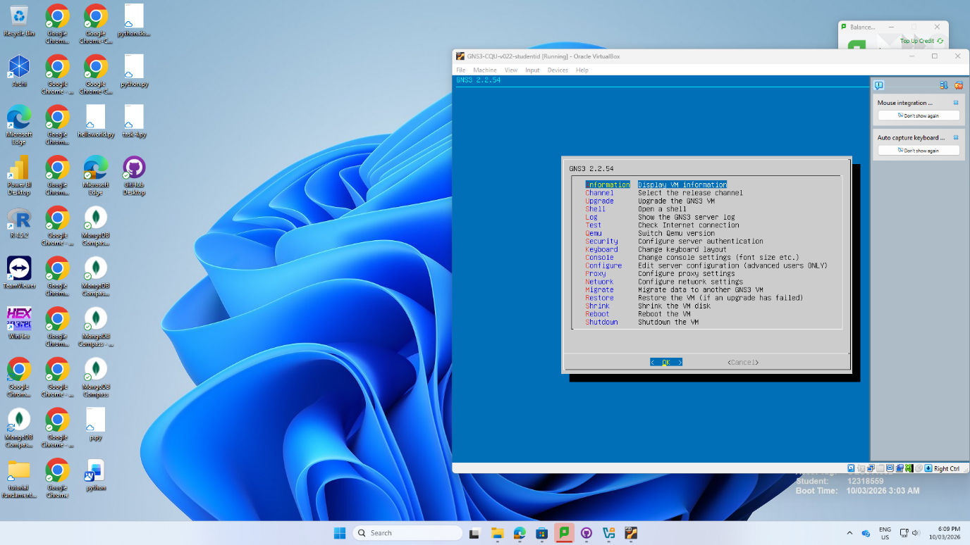
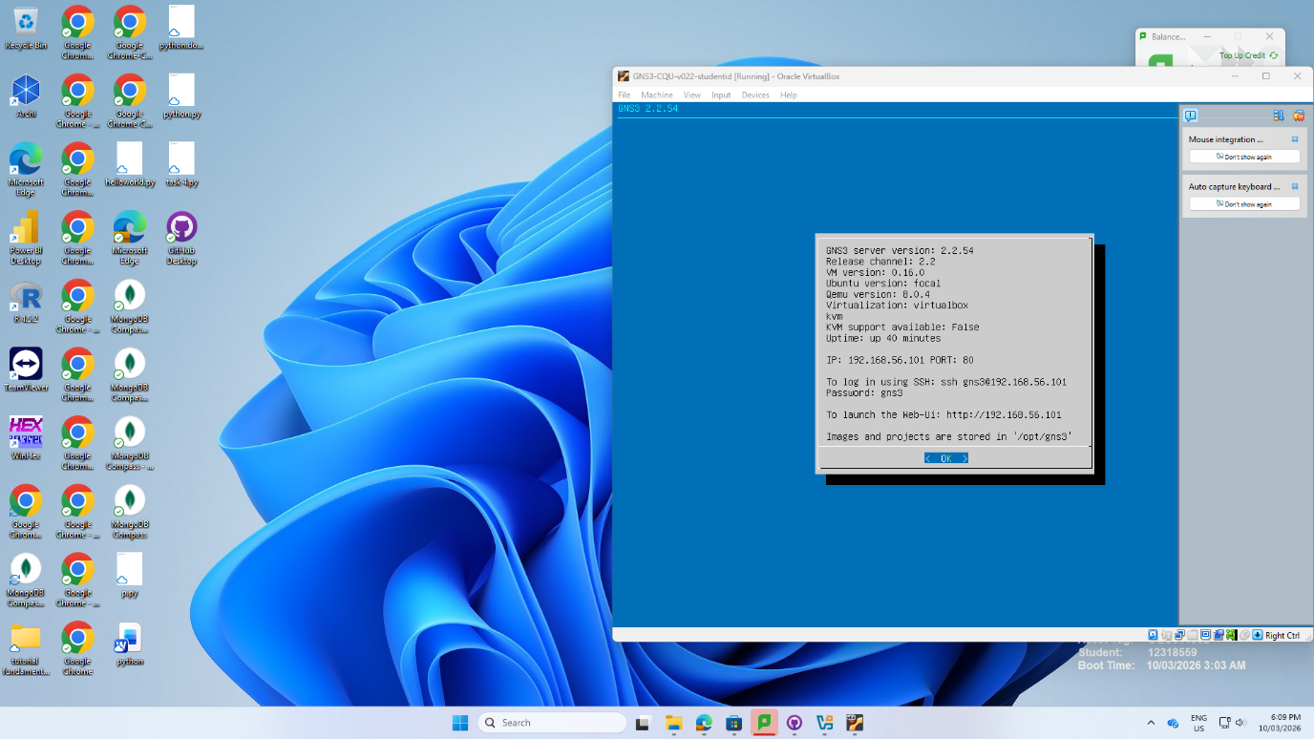

Step 2: Two hosts were added to make a topology. Student ID and names were added.
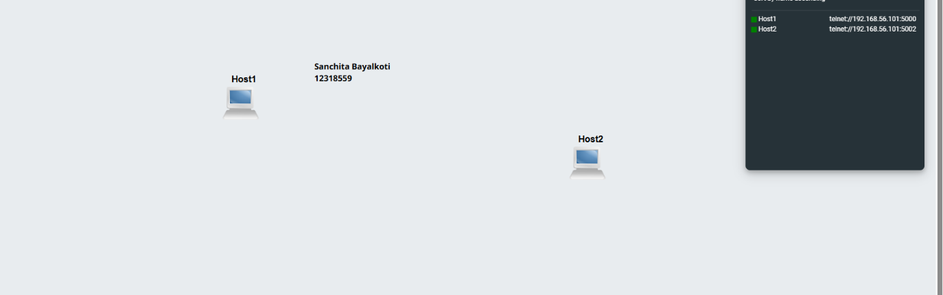
Step 3: The IP address of each host were changed. Since we didn’t need gateway, we didn’t change gateway. After all, I edit the configuration of the hosts.
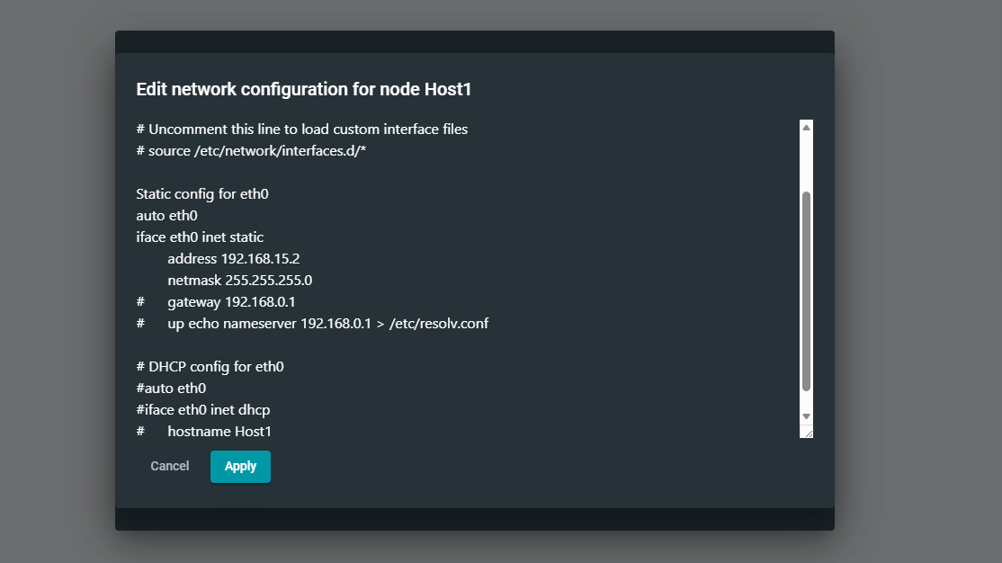
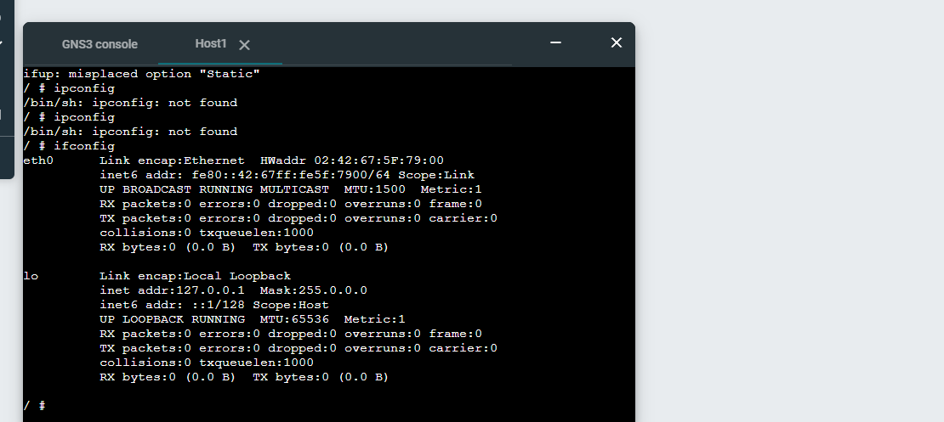
Step 4: Since the IP address was changed, we tried to see through web console (manually). I tried a command source /etc/network/interfaces.d/* to see the IP address. The image is given below. The IP address was changed successfully.
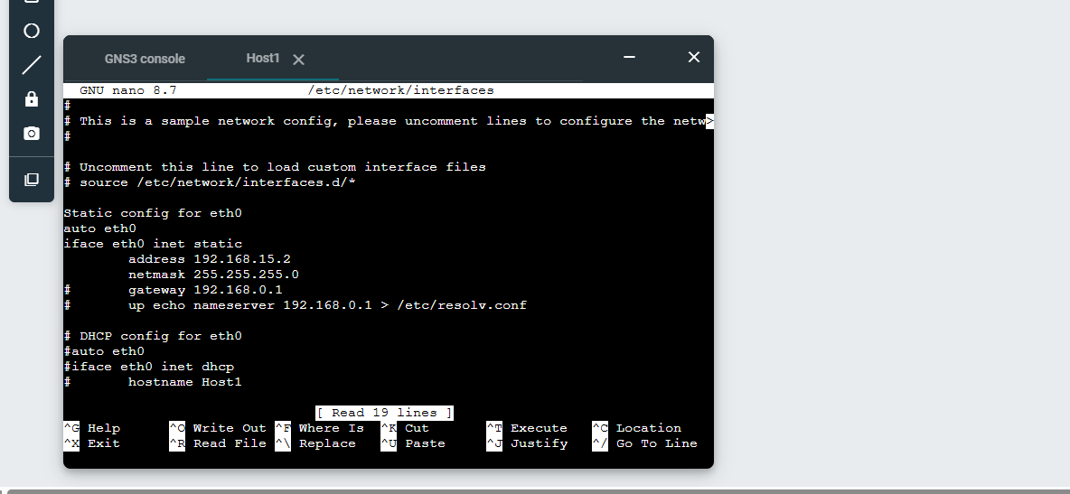
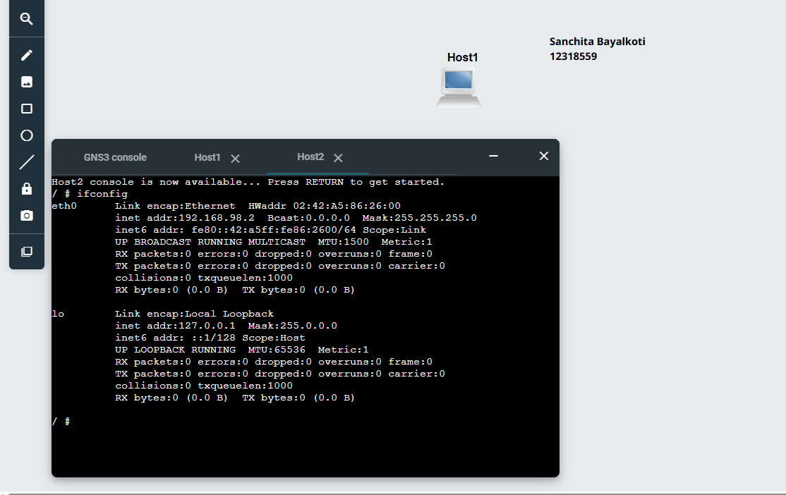

Step 5: The same way was followed to host 2. The IP address was changed successfully through GNU nano editor.
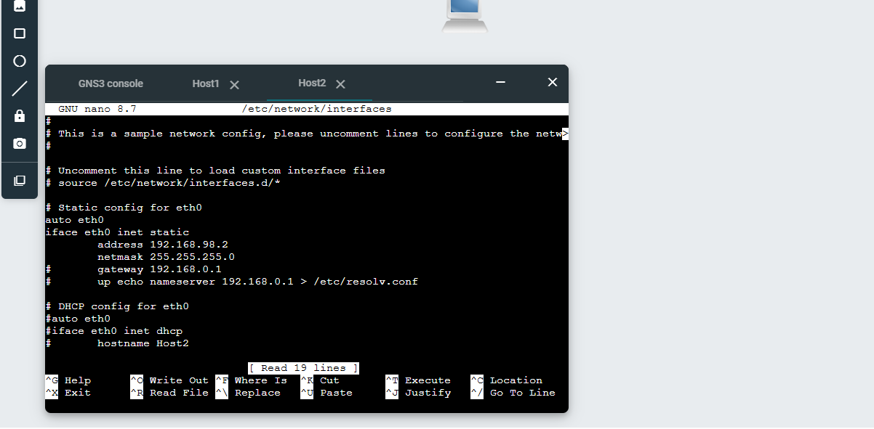
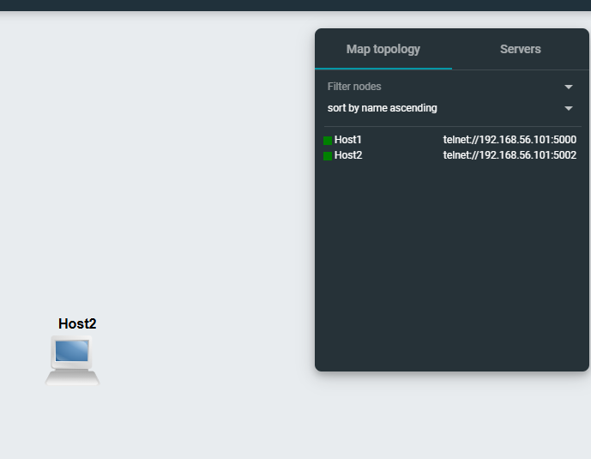
Reflection:
In Week 1, I learnt about fundamentals of network simulation. GNS3 was used to see IP address of the device. At first, I learnt to set/ change IP address of linux host manually. In addition, the error in the command /etc/network/interfaces taught us the importance of precise syntax. This tutorial taught us to change IP address manually and use command as well as I learnt to use GNS3.

